Intro to LlamaIndex: Document Ingestion and Chunking

- Loading source documents (usecase):
The document class serves as a container that stores a document's text in addition ​to providing each document with a unique ID and stores the document's metadata and relationships ​in dictionaries.
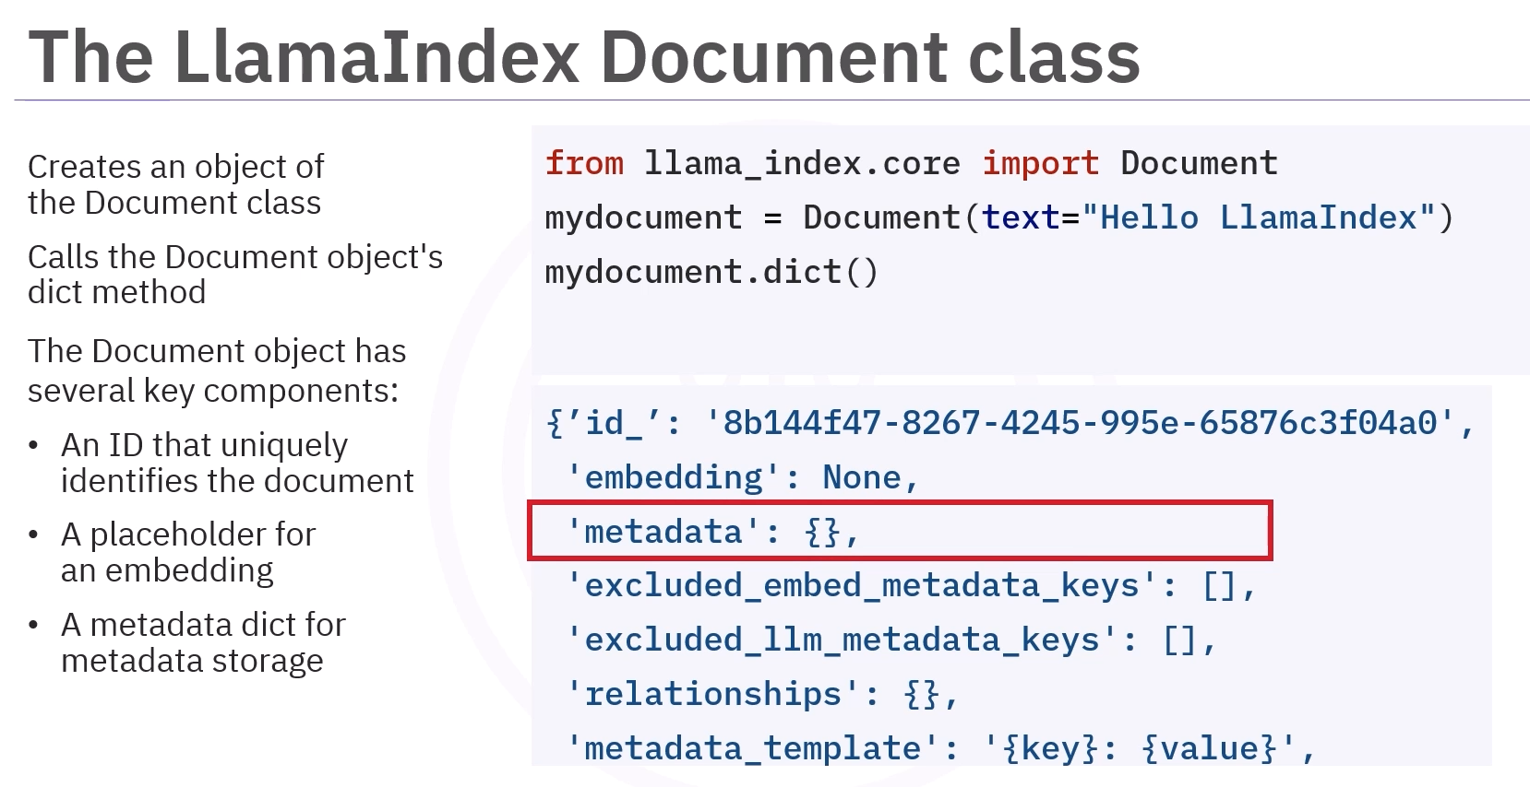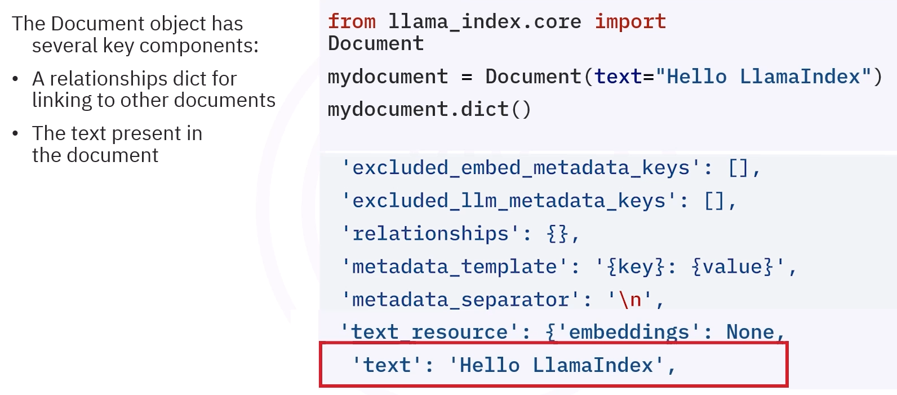

- Using SimpleDirectoryReader (usecase):
SimpleDirectoryReader that can load ​many file types including plain text, markdown, CSV, and PDF files. Think of SimpleDirectoryReader as a factory producing Document objects..
You can import the same by: from llama_index.core import SimpleDirectoryReader.
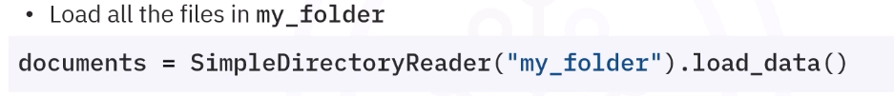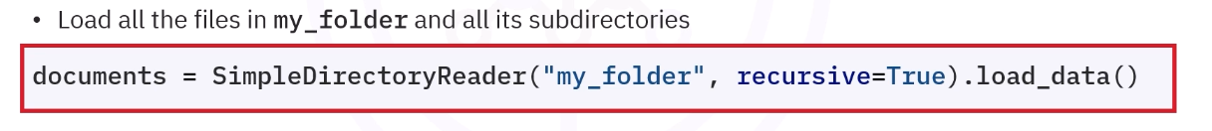
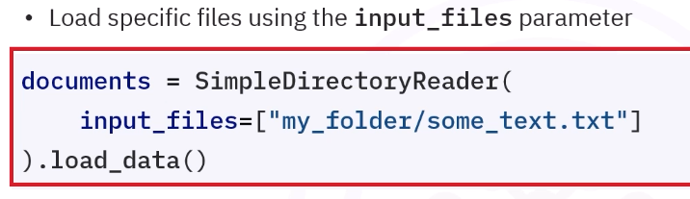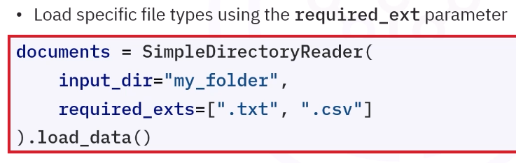

- Using Llamaindex nodes(usecase):
A LlamaIndex node is simply a text chunk. ​Chunking long text helps retain the specific context of each segment, leading to more precise ​and relevant embeddings.
